Handmade Face Mask
Non-Medical Cotton Face Coverings
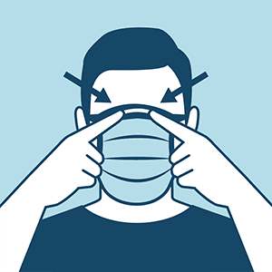
Please remember: wash your hands thoroughly when removing your mask and continue social distancing
Instructions
- First of all place the mask to your face and shape the nose wire to a nice snug fit
- Tie the top straps securely, then the bottom ties around the back of the neck
- Ensure a good fit that won’t move so you don’t have to keep touching your mask
- Remove carefully (avoiding the eyes) and machine wash on your regular cycle
- For extra protection we recommend wearing with glasses/sunglasses

Materials
- Your mask has been handmade in the UK using 3 layers of quilting cotton
- The flexible nose bridge is a wire paperclip surrounded by new memory foam
- Once washed your mask will become quite crinkley and will need to be ironed

Remember
- Wash your hands after removing your mask
- Do not use your mask if it becomes wet
- Remember to be careful not to touch your face while wearing your mask
- Cloth masks should only be used when medical grade masks are unavailable
If you have any questions please contact Fran at letclothesbeclothes@gmail.com

